ECR and ECS services
ECR elastic container register to store docker images (by default it stores in private repo but we can create public repo well)
ECSElastic container service to orchestration of container (to manage multiple container just like EKS and K8S )

1: To create docker image and push it to ECR
- Create and launch instance , configure aws cli and install docker
- Create a simple Dockerfile

Open aws console search ECR
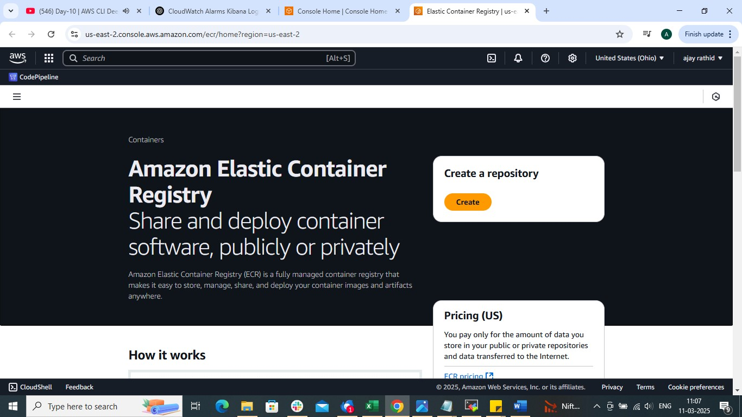
Give repo name (By default it will take private )
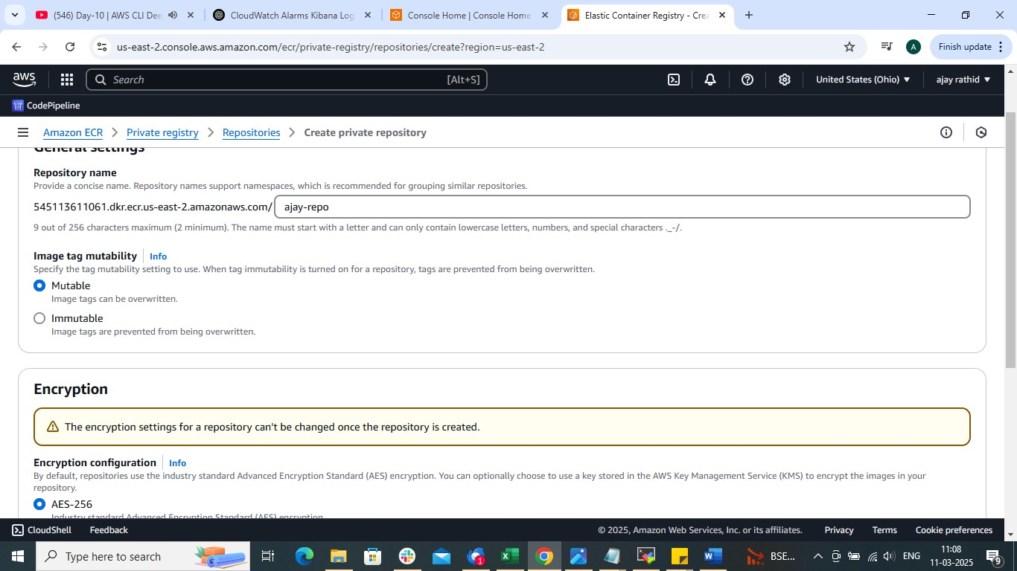

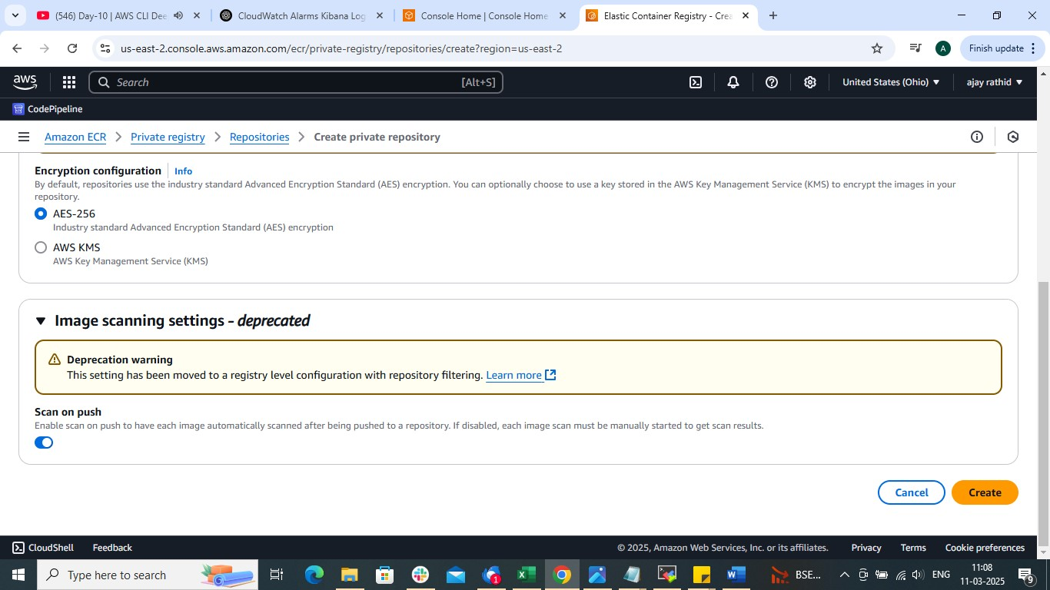

create
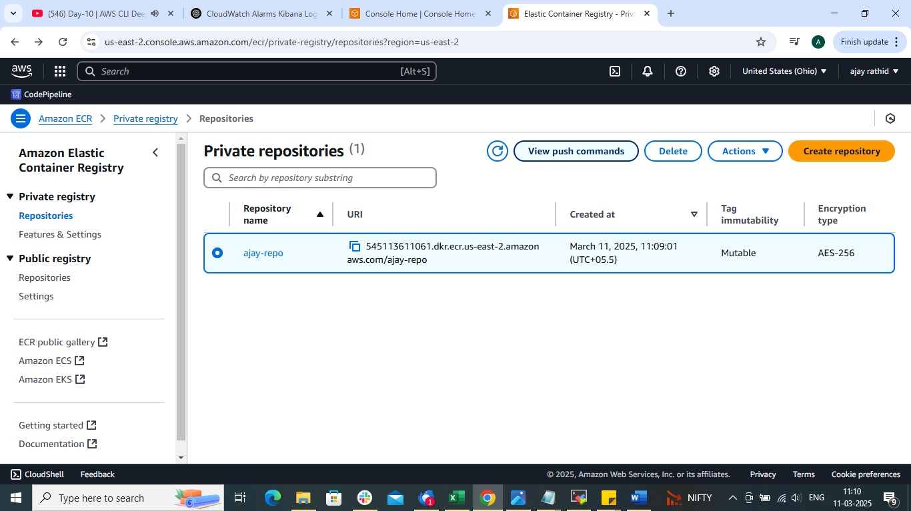

Now view push commands to login into ECR
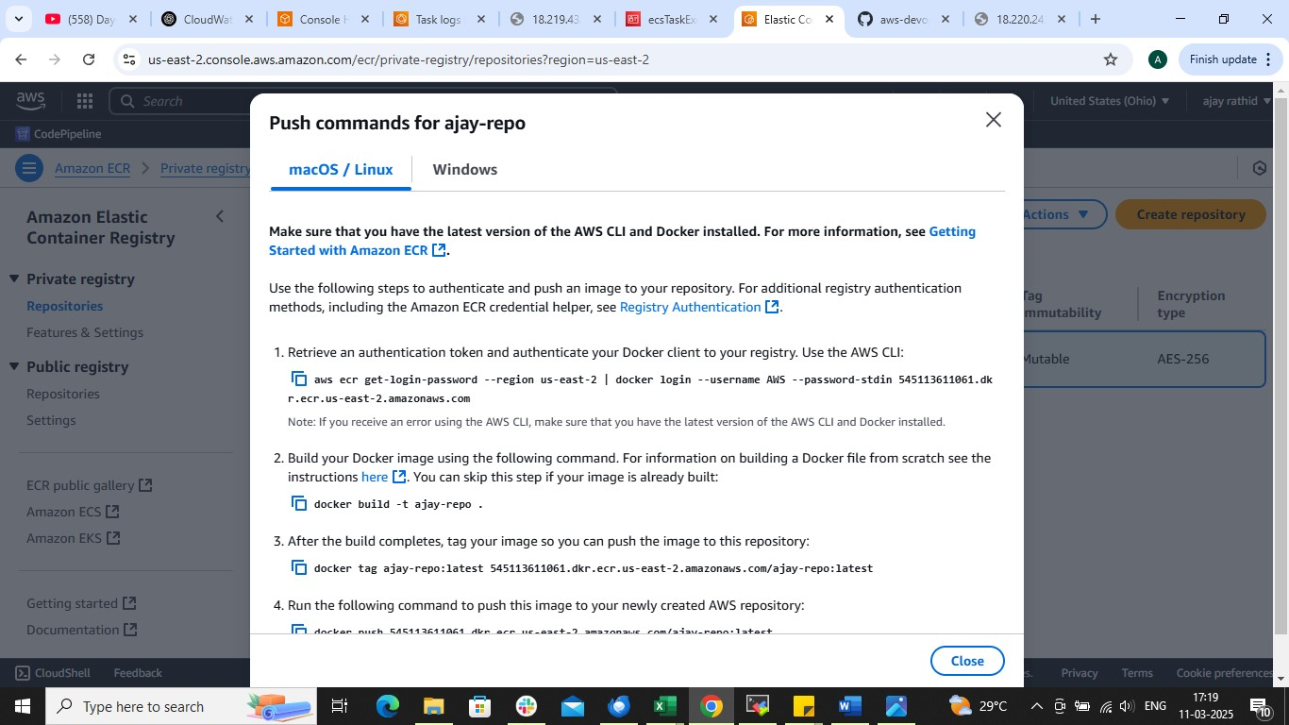

Now build the docker image
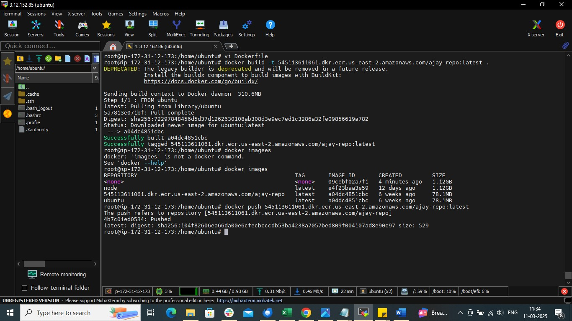

Push the docker image to ECR
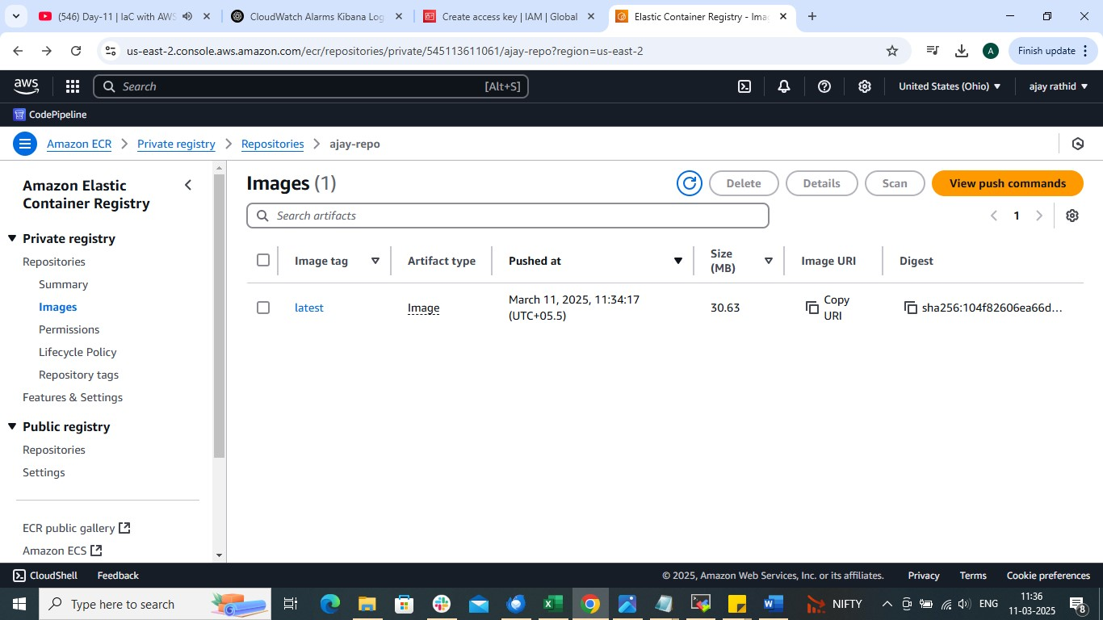
Now to deploy docker image using ECS

Search ECS in aws console and create cluster
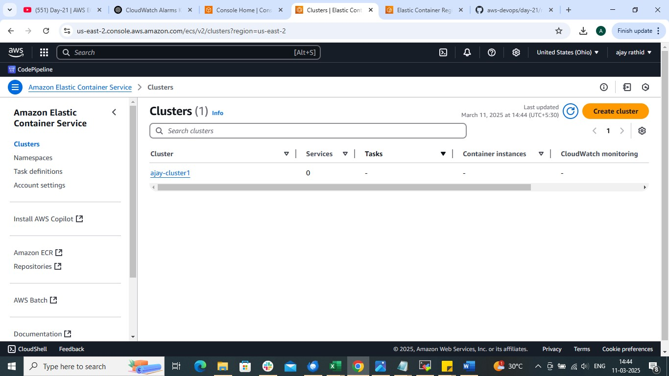

Create task definations
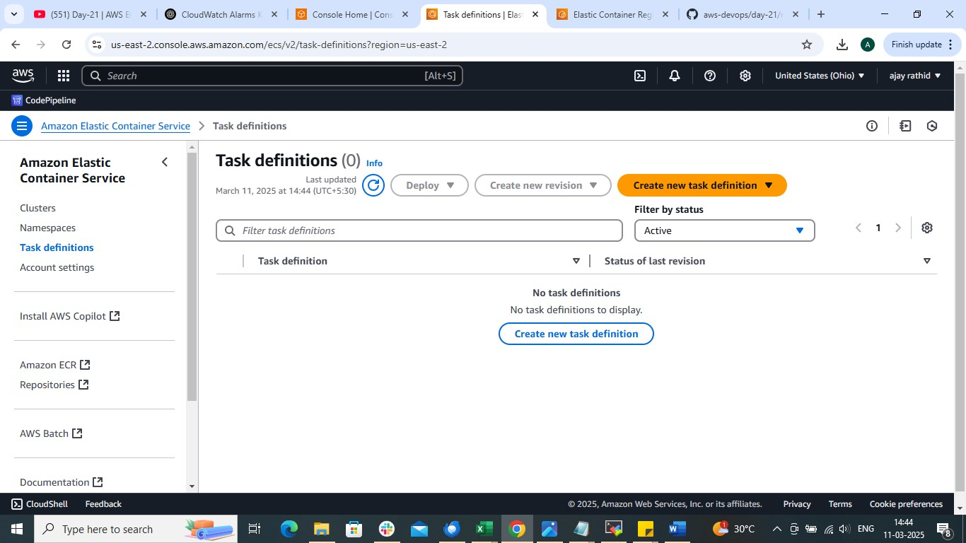
Choose aws fargate as launch type
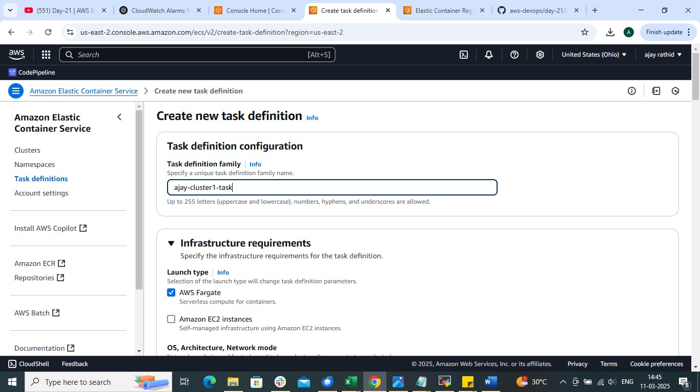

In container section use Image URI to which you want to deploy
Keep rest thing same and create

Now deployrun test
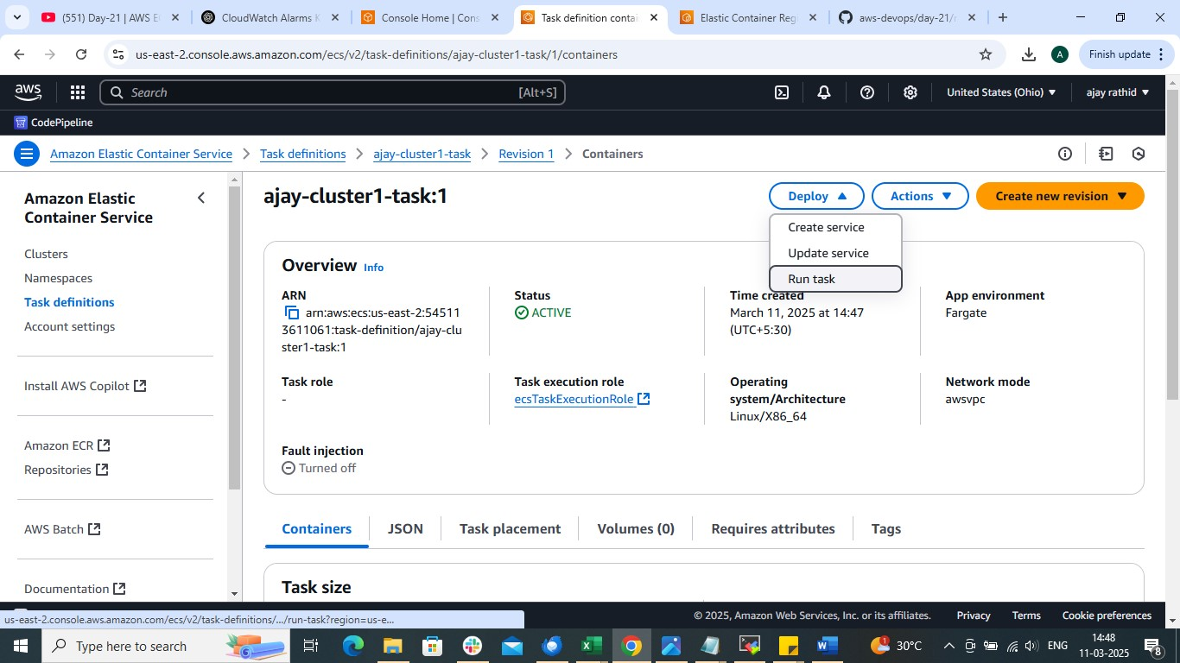

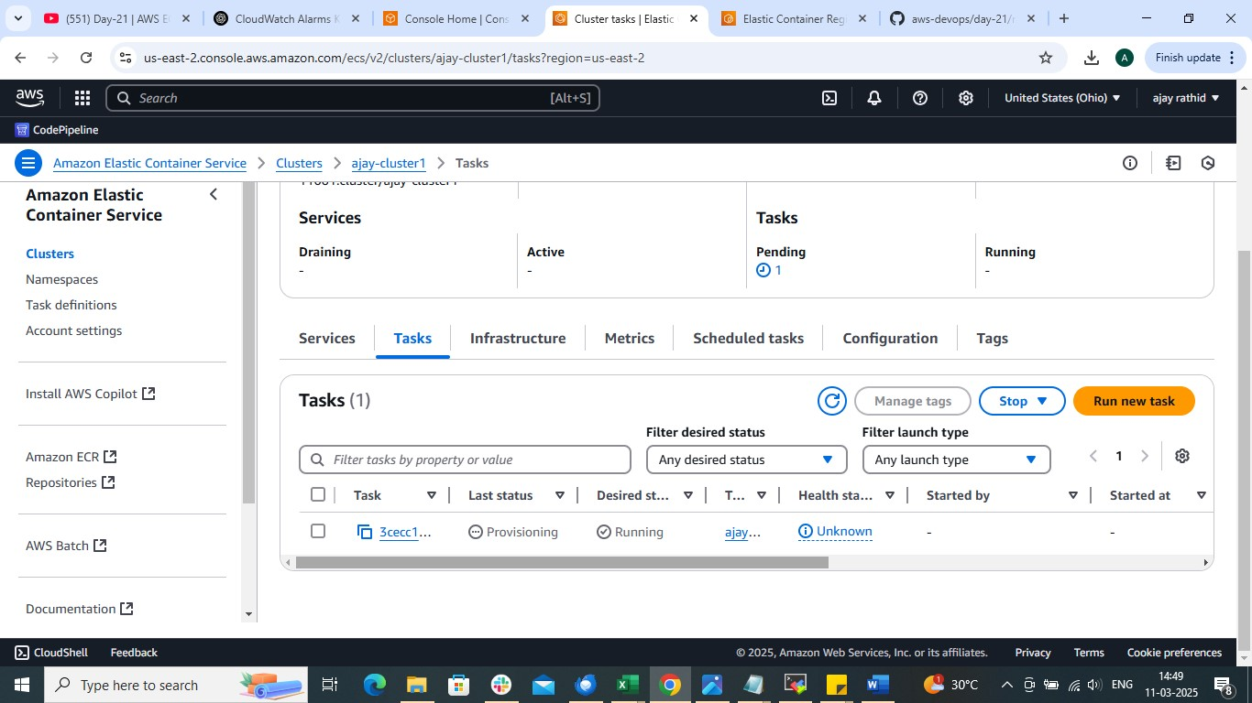

Use the public to access the application

